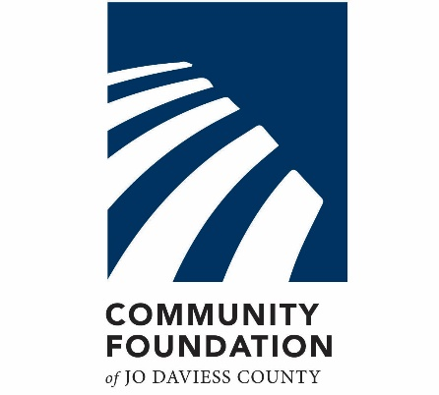
2021 FUTURE FUND
GRANT APPLICATION

Project Name (100 characters):

Project Description (7500 characters):

Amount Requested (20 characters):

Timetable for project (start/end dates) if applicable (100 characters):

What impact will this project have on the future of Jo Daviess County? (1500 characters):

Describe the partnerships supporting the project (1500 characters):

Describe other funding supporting the project (1000 characters):

Project Budget (upload PDF)

Organization Name (75 characters):

Organization Overview (500 characters):
Brief Background, your mission and key accomplishments in the community
Organization EIN (15 characters):

Organization Address:

Organization Website:

Fiscal Sponsor Information (if applicable)
If your agency does not hold nonprofit status, you may apply through a Fiscal Sponsor.

Fiscal Sponsor Name (75 characters):

Fiscal Sponsor EIN (15 characters):

Fiscal Sponsor Tax Status (75 characters):

Fiscal Sponsorship Agreement (upload)

Board Resolution (upload)
Upload Board Minutes or Board Resolution that states your organization is being fiscally sponsored and names the fiscal sponsor.

Applicant Contact Information

Applicant Name:

Applicant Position:

Applicant Email:

Applicant Phone:

